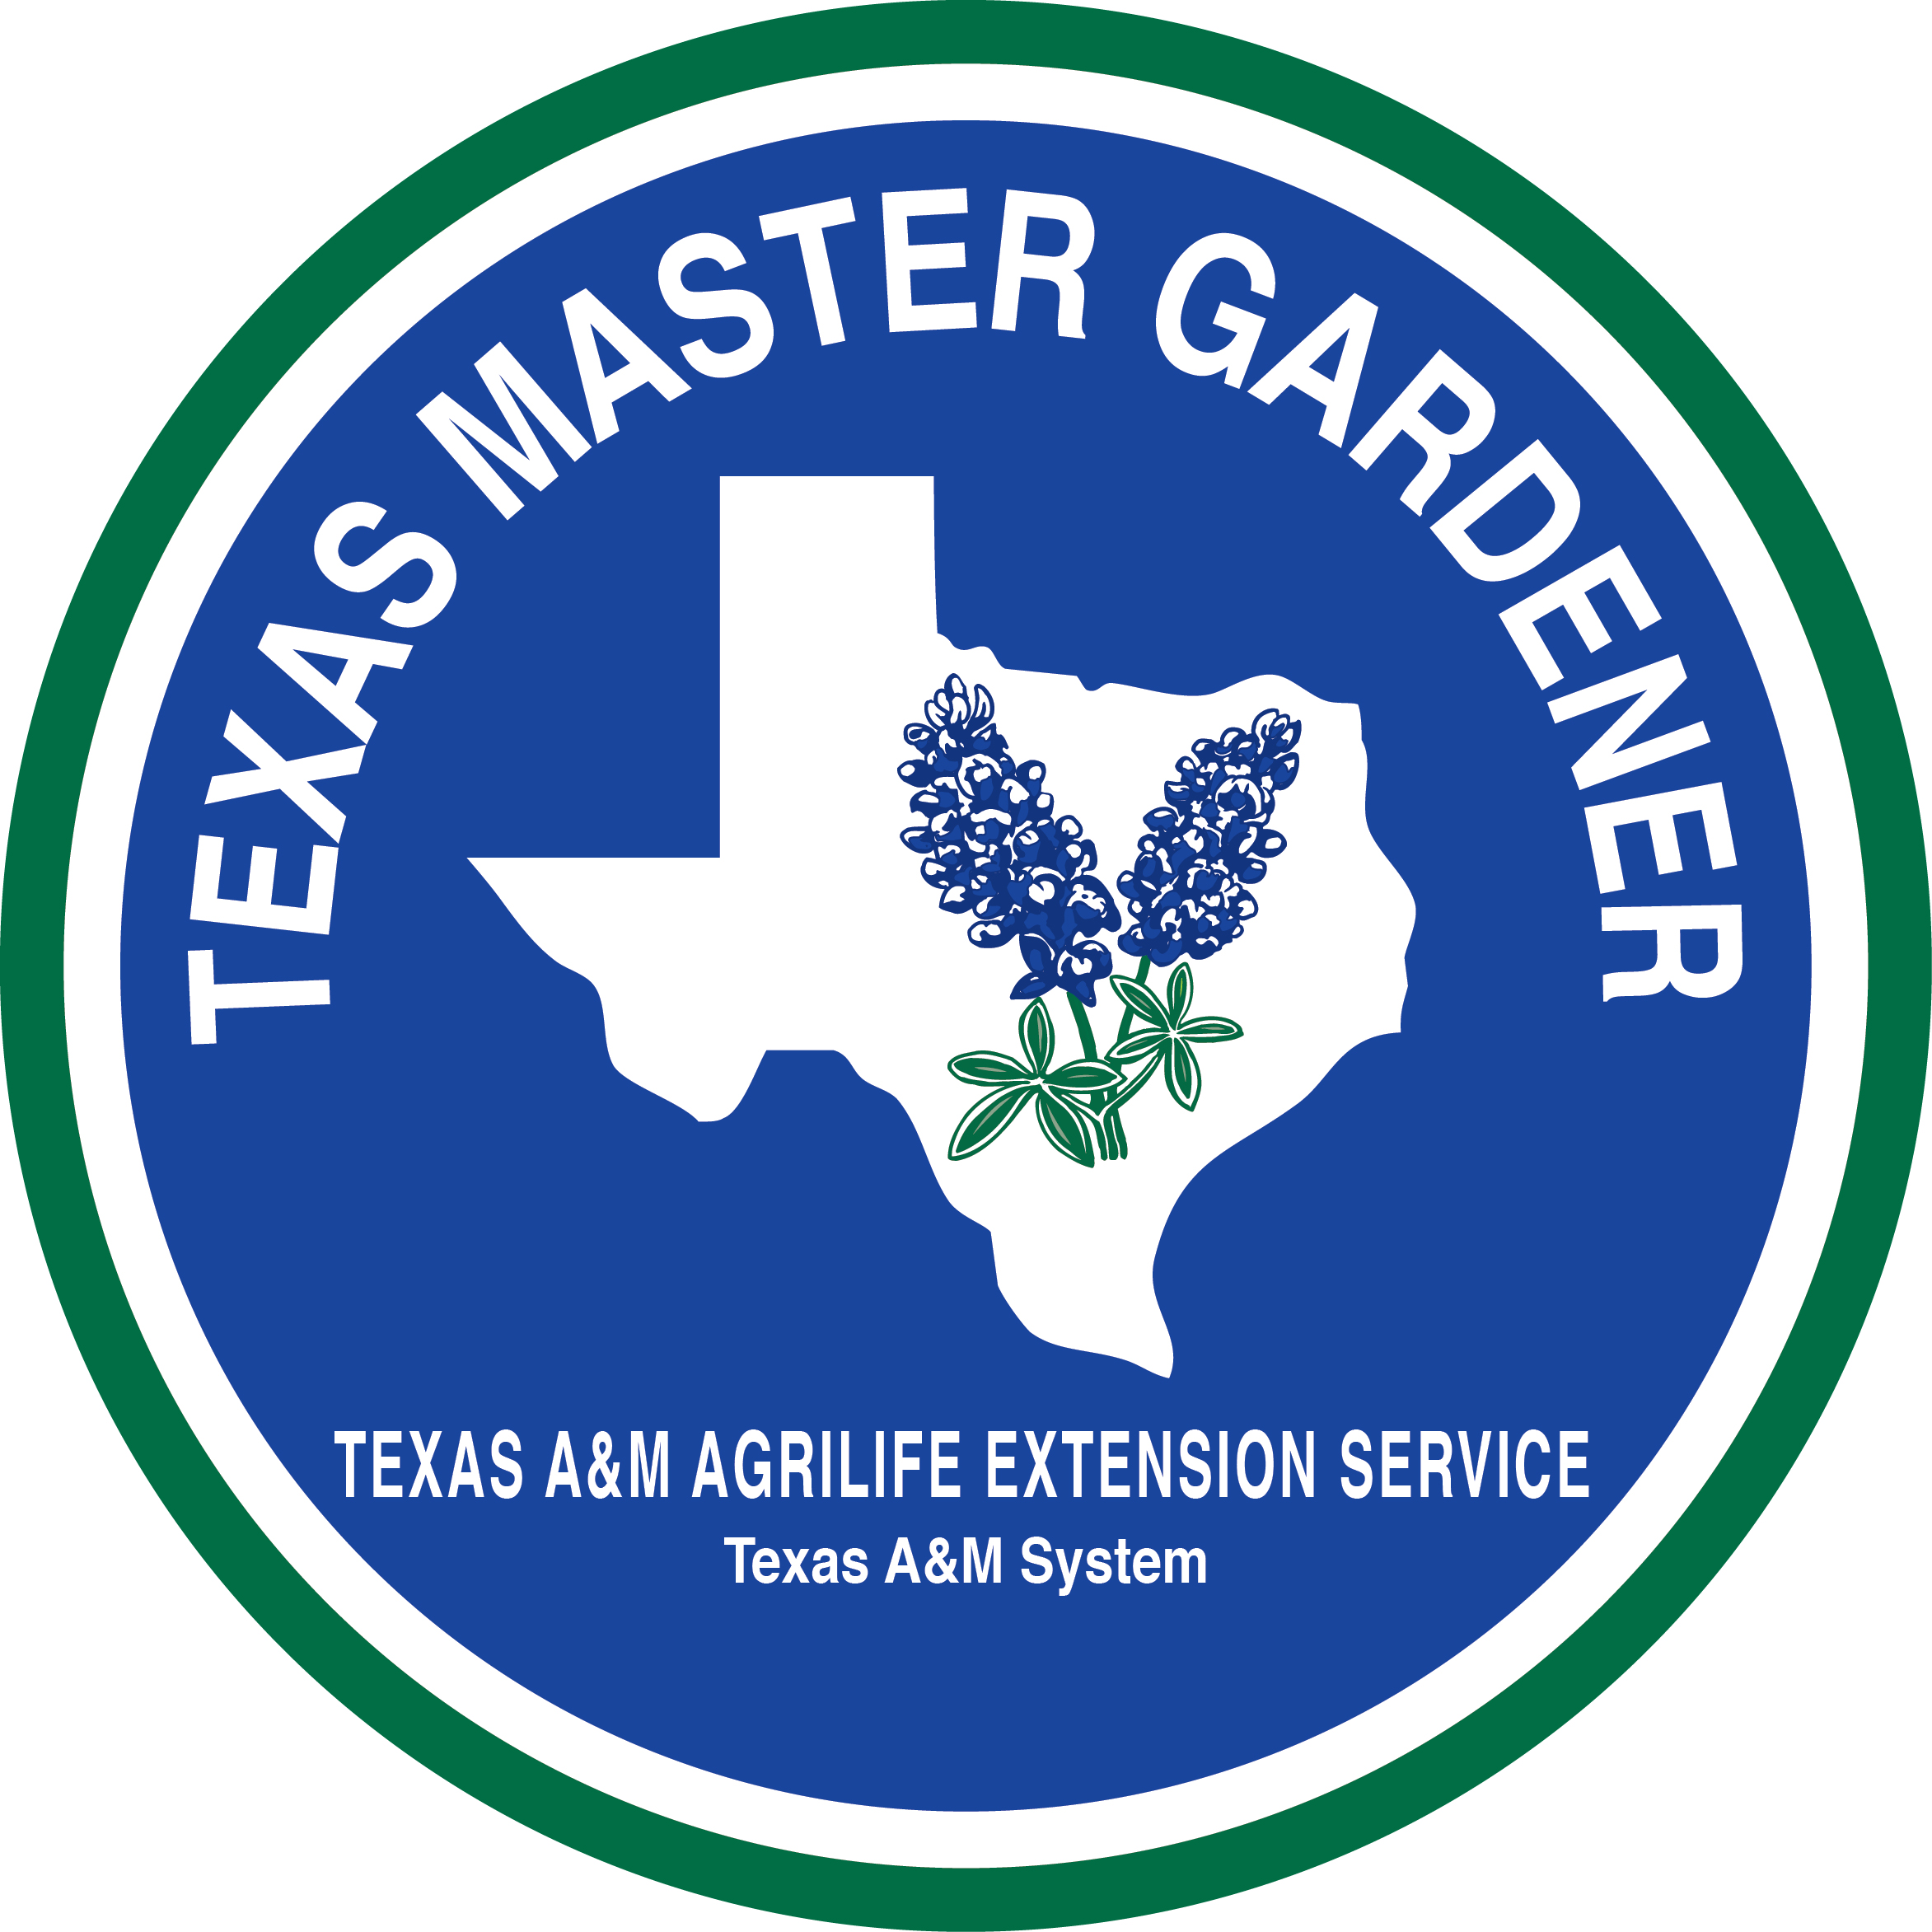
Aransas/San Patricio Master Gardeners
2016 Schedule—Brown Bags, Seminars, Classes & Events

Public Horticulture Education Series

Learn more on our website: aspmastergardeners.org
All events held at Texas A&M AgriLife Extension-Aransas County, 892 Airport Road, Rockport, unless otherwise indicated.

Tue Jan 19 BROWN BAG—“Spring Vegetable Garden”, Todd Cutting, Master Gardener, Noon–1:00 P.M.

Tue Feb 16 BROWN BAG— “Growing Citrus in Aransas County”, Bill Yant, citrus enthusiast, Noon–1:00 P.M. Meet at Bill’s citrus grove in Rockport. Please call 361-790-0103 by Feb 12 to register and to obtain address. Enrollment limited to 30 people.

Sat Feb 20 SEMINAR—“Gourds: From the Vine to the Design”, Stephanie Martin, Nueces Master Gardener, 10:00 A.M.--Noon.

Tue Mar 15 BROWN BAG—“Seasonal Native Plants”, Ellen Reisinger, Master Gardener, Master Naturalist, Noon–1:00 P.M.

Sat Mar 19 SPRING PLANT SALE—9:00 A.M–1:00 P.M. Coastal Oaks Garden at Texas A&M AgriLife Extension-Aransas County.

Sat Apr 2 —WORKSHOP - REGISTRATION REQUIRED, “Advanced Propagation”, Master Gardeners. Hands-on seminar, $15.00 advance fee required by March 28. Enrollment limited to 30. Call 361-790-0103 for information.

Tue Apr 19 BROWN BAG—“Drip and Low Water Irrigation”, Richard Snyder (“The Big Dripper”), Master Gardener, Noon–1 P.M.

Tue May 17 BROWN BAG—“Plumerias”, Annette Fowler, “The Plumeria Lady” and W.B. Ray “Fighting Texan,” Noon–1:00 P.M.

Tue Jun 21 BROWN BAG—“Termites”, Dr. Robert Puckett, Extension Entomologist, Texas A&M AgriLife Extension, Noon–1:00 P.M.

Wed Jul 13 INFORMATION & REGISTRATION SESSION—Become A Master Gardener, 1:30-3:00 P.M. Find out about the upcoming MG Intern Training weekly classes, August thru November.

Tue Jul 19 BROWN BAG—“Bees”, Gary Willison, Beekeeper, Noon–1:00 P.M.

Sat Aug 13 WORKSHOP— REGISTRATION REQUIRED “Pot People”, Linda Swiggett, Master Gardener/Master Naturalist, 10:00 A.M.--Noon. Hands-on garden art seminar, $12.00 advance fee required by July 23. Enrollment limited. Call 361- 790-0103 for information.

Tue Aug 16 BROWN BAG— “What Can I Do With My Herbs”, Judy Barret, Author, Editor and Gardener, Noon–1:00 P.M. Books will be available for sale and signing.

Tue Sep 20 BROWN BAG—“In Our Coastal Garden-What to Plant, Where”, Master Gardeners, Noon–1:00 P.M.

Sat Oct 1 FALL PLANT SALE—9:00 A.M.–1:00 P.M., Coastal Oaks Garden at Texas A&M AgriLife Extension-Aransas County.

Tue Oct 18 BROWN BAG—“Shade Gardening”, Kathy Huber, Landscape Designer, Gill’s Nursery, Noon–1:00 P.M.

Tue Nov 15 BROWN BAG—“The English Garden: Picturesque, Gardenesque and Wild"Historic Gardens”, Timothy Mullin, Fulton Mansion, Noon-1:00 P.M.

ARANSAS COUNTY OFFICE: Phone: 361-790-0103
Web site: http://aransas-tx.tamu.edu, Email: aransas-tx@tamu.edu

Individuals with disabilities, who require an auxiliary aid, service or accommodation in County Extension Office at least eight days prior to the program for assistance. Educational programs of the Texas AgriLife Extension Service are open to all people without regard to race, color, sex, disability, religion, age, or national origin.

